Softuniada 2019

Nexus
While studying arrays of various atoms, Doctor Sanity managed to discover a strange behaviour – while connecting 2 pairs of atoms from 2 parallel arrays, a nexus is initiated. If the 2 connections cross each other, the nexus disperses and loads all other atoms with nuclear value. He wanted to create an algorithm simulating this behaviour, but he’s too lazy… So you’ll have to write it for him.
You will receive 2 sequences of integers, separated by spaces – the 2 arrays of atoms.
After that you will start receiving 2 pairs of indices – the 2 connections in the arrays. Each connection will be in the form of an index from the first array and another index from the second array.
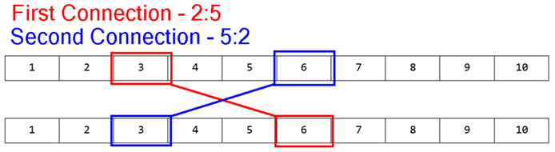
You must check if the 2 connections cross each other. If they do, you must remove all elements between them from both arrays, and you must increase all integers, that are left afterwards in both arrays, with the summed up value of the connected elements (Nexus value).
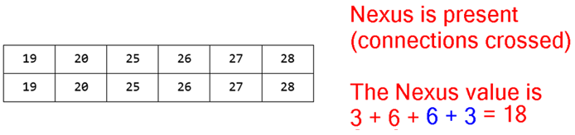
In case of no crossing of connections, you should do nothing.
You will continue receiving connections until you receive the command "nexus", at which point you must print what is left of the arrays and end the program.

Input
The input consists of several sequences:
- First you will receive 2 lines, containing sequences of integers, separated by spaces – the arrays.
- On the next several lines you will receive the pairs of connections in the following format:
{firstArrayIndex}:{secondArrayIndex}|{firstArrayIndex}:{secondArrayIndex}
- When you receive the command "nexus" the input must end.

Output
The output should consist of 2 lines, containing what is left of the arrays, with its elements – separated by each other with a comma and a space.

Constraints
- The input will always be in valid format.
- The arrays will contain integers in range [0, 10000].
- The arrays will not necessarily have the same length.
- The indices in the connections will always be valid and inside the arrays.
- Allowed time / memory: 100ms / 16MB.

Examples
Input | Output | Comment
1 2 3 4 5 6 7 8 9 10  1 2 3 4 5 6 7 8 9 10  2:5|5:2  nexus | 19, 20, 25, 26, 27, 28  19, 20, 25, 26, 27, 28 | See the examples above.
5 10 15 20 25 30  40 35 30 25 20 15 10 5  1:6|2:1  nexus | 75, 90, 95, 100  110, 75 | The range of the elements in the second array is larger than that of the first array.  Naturally, more elements are removed from the second array.
9 5 10 4 5 6 7 10  3 3 3 4 5 6 7 8  0:1|1:0  0:1|1:0  0:1|1:0  nexus | 634, 637  634, 635

